RPG manual prototype:

**Portal: Team Capture the flag**

**Game Pieces:** -Two Teams

-3 Players per team

-Heavy Bot

-Normal Bot

-Light Bot

-2 Companion Cubes at either end of the map

-1 normal six-sided die

-1 Six-sided die with arrows only

-variety of unique game maps to play on

**Victory Condition:** Players must strategically maneuver their way through the unique game map to recover the other team’s companion cube and return it to their own for victory.

**Movement:** each turn the player may choose to move all 3 Bots.

Heavy Bot

+2 hex movement

Bot

+3 hex movement

Light Bot

+5 hex movement

**Health:** Heavy Bot

+3 Heath-points

Normal Bot

+2 HP

Light Bot

+1 HP

**Combat:** To engage in combat a player must move one or more of his Bots onto an adjacent hex to one or more of the opposing player’s bots. This initiates a combat cycle.

Combat cycle will play out as follows: the *attacker* will roll the “directional die” to determine where on the game-board he will send the enemy bot via portal. The *attacker* will then roll the “normal die” to determine how many spaces (in the previously rolled direction) he will send the enemy bot. The enemy bot affected by the portal will then move to that location.

Booby-trapped hex locations: many hexes on the board will be marked as red hexes. These hexes will change depending on which board the players decide to play on. If at any point in time a red hex comes in between a bot and the hex that that bot is about to be *ported* to, the bot will take (1 damage).

Heavy bots can take 3 booby-traps (3dmg), Normal Bots can take 2, and light bots can take 1. If a bot runs out of HP, that bot is considered deactivated for no less than, 3 turns.

*if the location of a portal ends up going outside the boundaries of the game-board, this is considered an instant deactivation.

-upon reaching the 3rd turn of deactivation the Bot is reactivated at their respective companion cube location and may rejoin the game.

**Companion Cube Movement:** once a companion cube is picked up it is carried by that Bot until he is either deactivated via booby-traps, deactivated via ported off the game-board, or handed off to another bot.

-if a bot is deactivated via booby-trap the companion cube will remain in the hex location adjacent to the trapped hex, until picked up again.

-if a bot is deactivated via out of bounds the companion cube will remain on the nearest bordering hex to the edge the bot fell. It wil l remain there until picked up.

-a player CANNOT retrieve his own companion cube and return it, this will ensure game progression.

-once a companion cube is captured the game is over and the player who captures the opposing companion cube is the victor.

Companion Cube –Blue

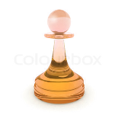 Companion Cube –orange

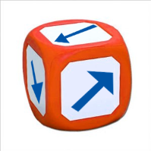Directional Portal die

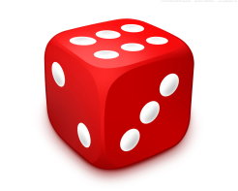Normal die

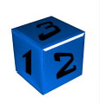Heavy Bot

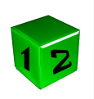Normal Bot

Light Bot

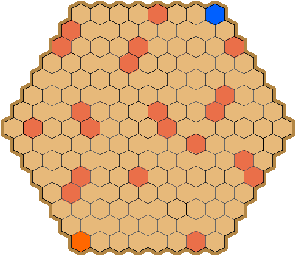

Game Board Example